**CLASS 14/12/2021**

**UG SEMESTER 3**

**GRAPH THEORY**



**THEORAM:** A graph is Euler if and only if all its vertices are of even degree.

Proof: Let us consider a connected graph G (V, E) is an Euler graph. So there exists an Euler line (closed walk) which traverses all the edges exactly once. If we trace the Euler line starting from an arbitrary vertex – we observe that when the trace enters a vertex with an edge it also exits the vertex with another edge as the walk is closed. It is true for any intermediate vertex and also true for the terminal vertex because we started the walk from there with an edge and ultimately at the end we end up at the same starting vertex when the walk ends. So every time we are entering a vertex we must exit the vertex hence it contributes degree 2 to the vertex. If a vertex is traversed multiple times that contribute degree multiple of 2 to that vertex. Hence the degree of every vertex is even.

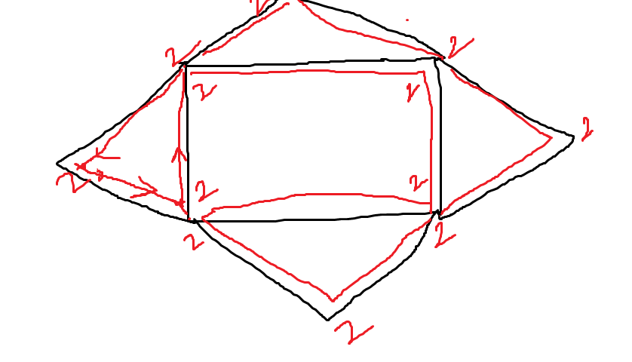

To prove the converse let us consider a connected Graph G(V,E) in which all vertices are of even degree.

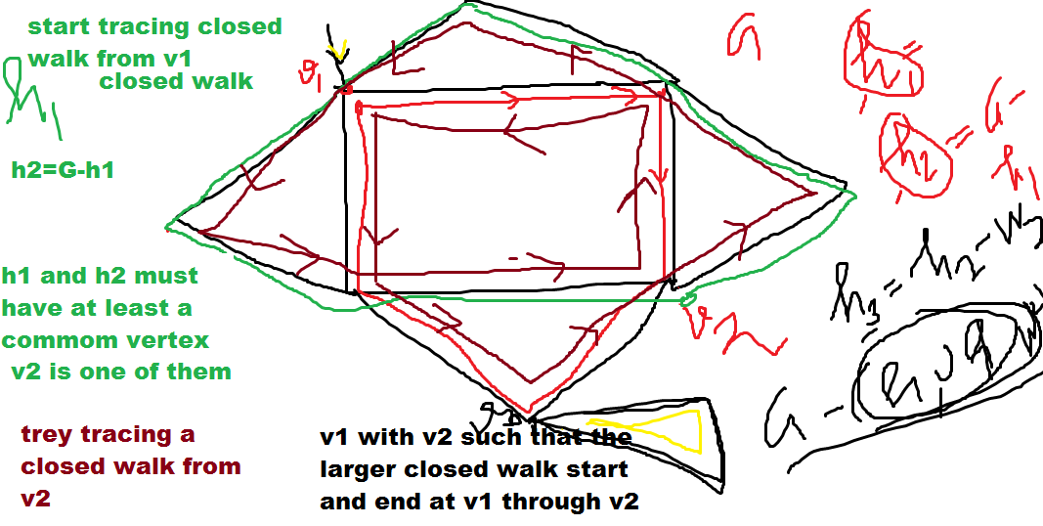

We start tracing a closed walk in G starting from vertex say v1. Now as each vertex has even degree when we enter a vertex we can exit it and the walk must end at vertex v1 as v1 also has even degree. Let the closed walk be w1.If w1 contains all edges of G then w1 is Euler line and G is Euler. If not we remove edges of w1 from G. The degrees of the vertices of the remaining graph G1 is also even. Now w1 sub-graph and G1 must have at least one vertex common as G is connected. Let one this common vertex be v2. We again start tracing a closed walk from v2 in G1. We try to trace the maximum edge closed walk. Let this closed walk id w2. Now w1 combined with w2 form another closed walk C1 which starts and ends at v1.Now if w2 contains all edges of G1 then this C1is an Euler line. Hence G is Euler. If not we again remove from G1 all the edges of w2. Now we similarly trace a closed walk w3 in G-C1. If again w3 contains all the edges of G-C1 then we combine C1 with w3 and form a closed walk which starts and ends at v1. Hence G is Euler. If not we again remove all the edges of w3 from G-C1 and repeat the same process until all the edges are exhausted. Hence the graph G is Euler. (Proved)

**Unicursal Graph**

Sometimes we can draw an open Euler line in a graph. An open Euler line in a graph is an open walk which traverses all the edges of the graph exactly once. A graph with an open Euler line is called a unicursal graph.

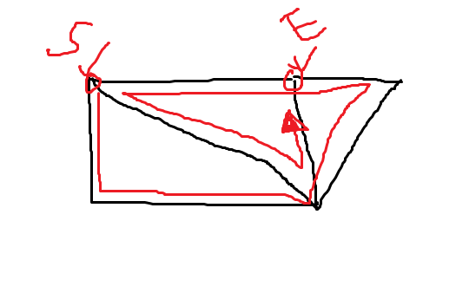

**Arbitrarily Traceable graph (from a vertex)**

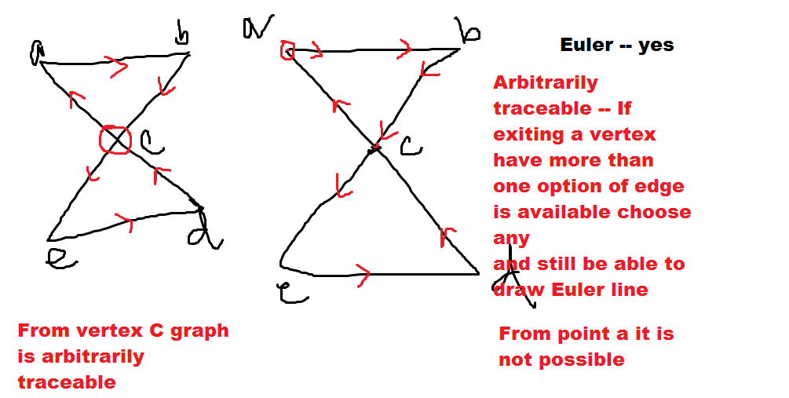

A graph G(V,E) is arbitrarily traceable from a vertex v if an Euler line can be traced in that graph by following the rule that when a walk from v arrives at any vertex then the walk further exits the vertex with any arbitrary edge not traversed in that vertex and still the Euler line can be drawn.

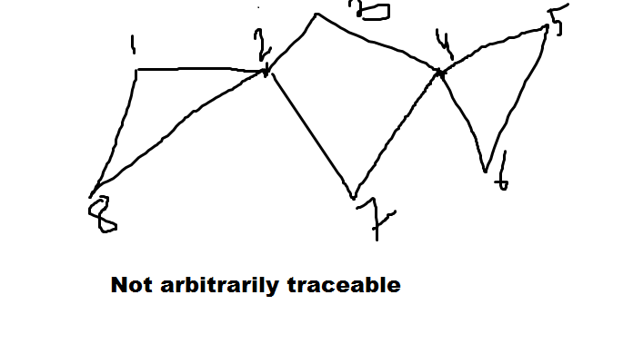

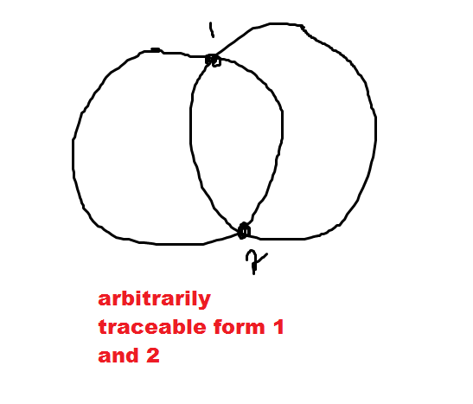

**Theorem:** An Euler graph G is arbitrarily traceable from a vertex v if and only if all the circuits of G passes through v.

**Operations on Graph**

**Union :** of two graphs G1(V1,E1) G2(V2,E2) is G3(V3,E3)=G1 $∪G2$ whose vertex set V3=V1 $∪V2$ and E3=E1 $∪E2$

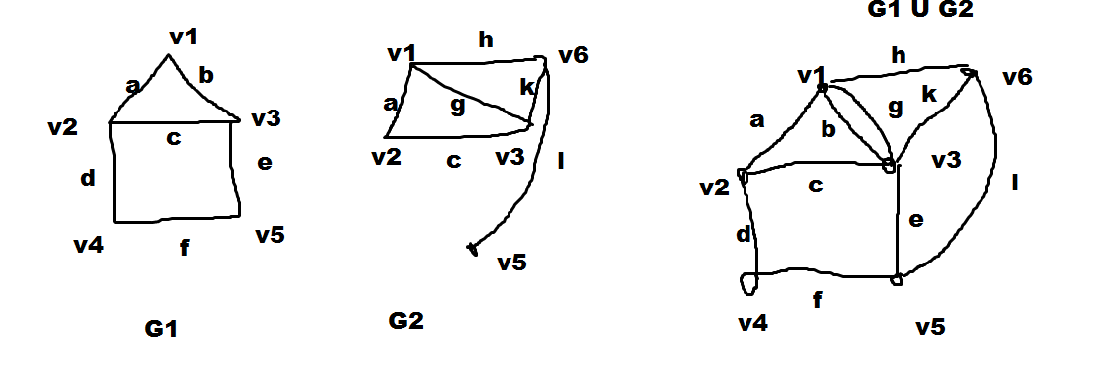

**Intersection:** of two graphs G1(V1,E1) G2(V2,E2) is G3(V3,E3)=G1 $∩G2$ whose vertex set V3=V1 $∩V2$ and E3=E1 $∩E2$

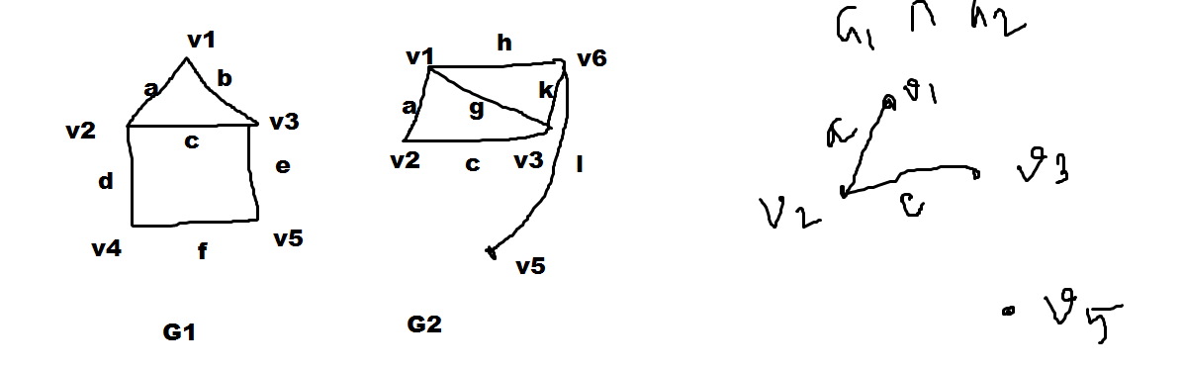

**Ring Sum ($⊕$):**of two graphs G1(V1,E1) G2(V2,E2) is G3(V3,E3)=G1 $⊕G2$ whose vertex set V3=V1 $U V2$ and E3=Take those edges that are in E1 or in E2 but not in both.

